**PREPAID AND POSTPAID EV CHARGING STATION**

Dr.satyabhrata singha 1B.Nikhil 2,M.Shashikanth3,R.Anil kumar reddy4,B.p.charan teja goud5,

Professor1, UG Student2, 3, 4,5, Department of Electronics & Communication Engineering, Bharat Institute Of Engineering &Technology, Mangalpally, Telangana,501510.nikhilbachu739@gmail.com2,shashikanthrathod80@gmail.com9513,

Rotteanilkumarreddy6@gmail.com4 ,pandalacharan01@gmail.com5

# ABSTRACT

*Electric vehicles (EVs) are becoming more common, and there is a growing need for an easy and flexible charging system. This project presents a dual-mode EV charging setup that works with both prepaid and postpaid payment options. Users can start charging by scanning an RFID card. In prepaid mode, the system deducts money from the user's balance based on the amount of electricity used. In postpaid mode, users are charged after the charging session. This makes the system suitable for different types of users and helps manage billing more effectively. To ensure accurate tracking of electricity use, the system uses voltage and current sensors. A microcontroller like Arduino or ESP32 controls the process by reading sensor data, managing the relay that starts or stops charging, and checking user balance or billing status. The system also displays important information like energy usage, balance, and charging time on an LCD screen or web interface. Overall, this project provides a reliable and user-friendly solution for EV charging stations, making them more efficient and convenient*

# I. INTRODUCTION

The shift from fossil fuel-powered vehicles to electric vehicles (EVs) is reshaping modern transportation, creating a growing need for secure and efficient charging infrastructure. Traditional systems often lack personalized user authentication and accurate energy tracking, leading to inefficiencies and billing errors. This project introduces a smart EV charging system that addresses these issues by incorporating RFID-based user identification, supporting both prepaid and postpaid billing models. The prepaid model automatically halts charging when the user's balance runs out, while the postpaid model tracks usage for later billing. Equipped with current and voltage sensors, the system enables real-time monitoring of power consumption. A relay automates the charging process, switching it ON or OFF based on user status to ensure safety and efficiency. This intelligent setup offers transparent billing, improved energy management, and user convenience, supporting the broader goal of promoting sustainable transportation.

# II. PROBLEM STATEMENT

Electric vehicle (EV) users often encounter issues such as rigid billing models, limited usage transparency, and inadequate security in current charging systems. Many existing solutions either support only postpaid billing or fail to monitor real-time power consumption, leading to inefficiencies, energy wastage, and reduced user control. These shortcomings highlight the need for a more advanced and adaptable charging infrastructure. A smart EV charging system is essential—one that supports both prepaid and postpaid billing options while ensuring accurate energy monitoring. By integrating user authentication and automated power control, such a system can enhance security, improve efficiency, and offer a more user-centric experience. Real-time tracking of power consumption not only ensures transparent billing but also enables users to better manage their energy usage. This approach promotes accountability and paves the way for a more reliable and secure EV charging network, ultimately supporting the broader adoption of electric vehicles.

# III. METHODOLOGY

The proposed system introduces a smart EV charging station designed to enhance flexibility, efficiency, and security in electric vehicle charging. It incorporates RFID-based authentication to accurately identify users before initiating the charging process. A dual billing mechanism is implemented, offering both prepaid and postpaid options. In the prepaid mode, the system deducts the charging cost directly from the user's existing balance, while in the postpaid mode, it tracks energy usage for billing at a later time. Voltage and current sensors are integrated to continuously monitor power consumption during charging. A microcontroller, such as an Arduino or ESP32, serves as the core processor, responsible for reading sensor data, computing energy usage, and managing overall system functions. The relay module, controlled by the microcontroller, enables or disables the power supply to the vehicle based on the user’s balance or tracked usage. This smart system provides a reliable and user-friendly solution adaptable to various EV charging scenarios.

# IV. BLOCK DIAGRAM

Fig: Block Diagram

**V. COMPONENTS USED**

# 1. ARDUINO UNO

The Arduino UNO is a widely used open-source microcontroller board based on the Microchip ATmega328P microcontroller and developed by Arduino. The board is equipped with sets of digital and analog input/output (I/O) pins that may be interfaced to various expansion boards (shields) and other circuits The board features 14 Digital pins and 6 Analog pins. It is programmable with the Arduino IDE (Integrated Development Environment) via a type B USB cable. It can be powered by a USB cable or by an external 9 volt battery, though it accepts voltages between 7 and 20 volts. It is also similar to the Arduino Nano and Leonardo.

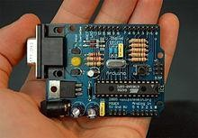

Fig: ARDUINO UNO

# 2.RFID TAG

The RFID billing solution assists in auto identification of products and automatic processing of transactions. It involves the use of an RFID reader on a Raspberry Pi to automatically scan for RFID tags with a unique code placed on products within the cart. This eliminates the process of barcodes being read manually, decreasing errors and making it more efficient. The use of RFID increases efficiency in shopping and assists business owners in stocking their shelves effectively,



Fig: Radio Frequency Identification (RFID)

# 3. RELAY MODULE

The relay module is a crucial component in the proposed RFID-Based Electric Vehicle Charging Station, enabling the automated control of the charging process. It acts as an electrical switch that allows or interrupts the flow of current between the power source and the EV battery, ensuring efficient and safe charging.

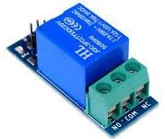

Fig: RELAY MODULE

# 4. LCD DISPLAY

LCD (Liquid Crystal Display) screen is an electronic display module and find a wide range of applications. A 16x2 LCD display is very basic module and is very commonly used in various devices and circuits. These modules are preferred over seven segments and other multi segment LEDs. The reasons being: LCDs are economical; easily programmable; have no limitation of displaying special & even custom characters (unlike in seven segments), animations and so on.

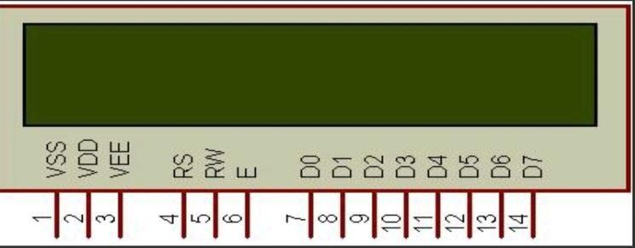

Fig.16*2 LC

## **5. RFID READER:**

An RFID (Radio Frequency Identification) scanner operates similarly to a barcode scanner but uses electromagnetic waves instead of laser beams to read data. The scanner emits radio signals through its antenna, which are received by the antenna on an RFID tag. When the tag detects the incoming signal, it activates and sends the stored data from its internal chip back to the scanner. This exchange of information occurs wirelessly, making RFID systems more efficient and capable of scanning multiple tags without direct line-of-sight. The data on the RFID tag is stored in either Read-Only Memory (ROM) or Read/Write Memory. ROM-based tags contain fixed data that cannot be changed after manufacturing, commonly used for identification purposes. Read/Write Memory tags, on the other hand, are more flexible, allowing data to be modified or updated using compatible devices. RFID technology is widely used in applications such as access control, inventory management, contactless payments, and vehicle tracking.

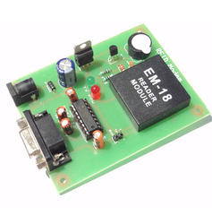

Fig: RFID READER

**6. CURRENT TRANSFORMER:**

A current transformer (CT) is an electrical device used to measure alternating current (AC) by producing a reduced current proportional to the current in its primary circuit. It consists of a primary winding, a magnetic core, and a secondary winding. The primary winding carries the main current, while the secondary winding, connected to measuring instruments or protective relays, outputs a scaled-down current. CTs are essential in power systems for monitoring and protection, especially in high-voltage networks where direct measurement is impractical. They provide electrical isolation between the high-voltage circuit and measuring instruments, enhancing safety. CTs are commonly rated by their transformation ratio (e.g., 1000:5), meaning a 1000 A primary current results in a 5 A secondary current. Accuracy, burden (load), and class are key specifications. They should never be operated with an open secondary circuit while energized, as this can cause dangerously high voltages.

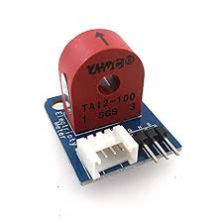

Fig. current Transformer

**7.VOLTAGE REGULATOR**

A voltage regulator is an essential electronic component used to maintain a constant output voltage level, regardless of variations in input voltage or load conditions. In EV charging systems and other electronic circuits, voltage regulators ensure that sensitive components receive a stable power supply for reliable operation. They protect the system from voltage fluctuations that could otherwise damage components or disrupt performance.

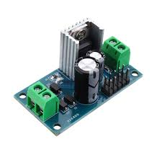

Fig. voltage sensor

**RESULT:**

This project presents a smart and secure electric vehicle (EV) charging system using RFID technology. It allows only authorized users to access the charging station by scanning an RFID card. The system includes a voltage sensor and an LCD display to show real-time charging status. A relay module is used to safely control the power supply. This setup makes EV charging more convenient, automated, and efficient.

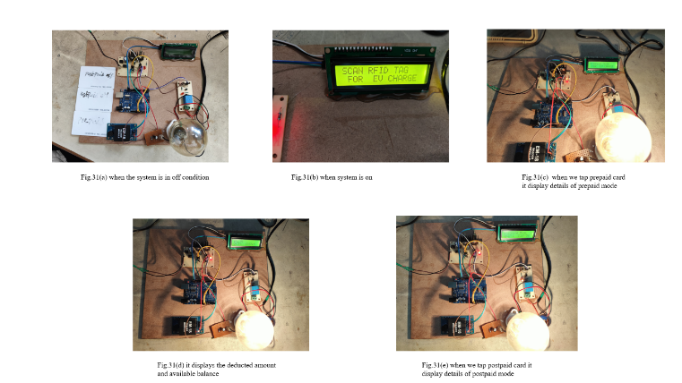

**REFERENCES:**

[1] 2025, International Journal of Scientific Research in Engineering and Management (IJSREM) Volume 9, Issue 4, April 2025 – Dr. D. Siva, S. Jameela, P. Lavanya, V. Surendra “Department of Electronics & Communication Engineering, Sai Rajeswari Institute of Technology, Proddatur, Andhra Pradesh” titled as SMART RFID IOT ENABLED EV CHARGING SYSTEM.

[2] 2024, Major Project Report – Vyankatesh Chavan, Aniket Kahandal, Sujal Sonavane, Ankur Saxena “Department of Electronics and Telecommunication Engineering, Sandip Institute of Technology and Research Centre, Nashik, Maharashtra, India” titled as PREPAID & POSTPAID BILLING FOR EV CHARGING STATION.

[3] 2022, IEEE International Conference on Smart Grid Communications (SmartGridComm) – J. Liu, X. Wang, Y. Zhang titled as RFID-BASED SMART CHARGING STATION FOR ELECTRIC VEHICLES.

[4] 2021, IEEE Transactions on Industrial Electronics Volume 68, Issue 5, May 2021 – M. Patel, P. Shah, D. Joshi titled as DESIGN AND IMPLEMENTATION OF AN RFID-BASED AUTHENTICATION SYSTEM FOR EV CHARGING.

[5] 2022, IEEE Power and Energy Conference – A. Sharma, V. Kumar titled as SMART GRID-BASED EV CHARGING STATION USING RFID AUTHENTICATION AND IOT INTEGRATION.

[6] 2023, IEEE Internet of Things Journal Volume 9, Issue 3, February 2023 – T. Chen, L. He, W. Zhang titled as RELAY-CONTROLLED ELECTRIC VEHICLE CHARGING STATION WITH RFID-BASED USER AUTHENTICATION.

[7] S. Negarestani, M. Fotuhi-firuzabad, M. Rastegar, A. Rajabi-ghahnavieh, Optimal Sizing of Storage System in a Fast-Charging Station for Plug-in Hybrid Electric Vehicles 2 (4) (2016) 443– 453.

[8] S. Negarestani, M. Fotuhi-firuzabad, M. Rastegar, A. Rajabi-ghahnavieh, Optimal Sizing of Storage System in a Fast-Charging Station for Plug-in Hybrid Electric Vehicles 2 (4) (2016) 443– 453.

[9]I. S. Bayram, G. Michailidis, M. Devetsikiotis, B. Parkhideh, “Strategies for Competing Energy Storage Technologies for DC Fast Charging Stations”, 2012 IEEE Third International Conference on Smart Grid Communications, Smart Grid Comm 2012

[10]Mburu, P. T., & Sathyamoorthi, C. R. (2014). Switching from post-paid to pre-paid models: customer perception and the organisational role in managing the change: a case study of botswana power corporation. Journal of Management Research, 6(3), 175.